 

**Placement Empowerment Program**

***Cloud Computing and DevOps Centre***

**DAY 12 TASK:**

Set Up a Cloud-Based Monitoring Service Enable basic cloud monitoring (e.g., Cloud Watch on AWS). View metrics like CPU usage and disk I/O for your cloud VM.

Name: Shahana.M.S Department: ADS



**Introduction**

**Cloud-based monitoring services help track the performance and health of cloud resources in real time. Monitoring tools like AWS CloudWatch, Azure Monitor, and GCP Cloud Operations provide insights into metrics such as CPU usage, memory utilization, disk I/O, and network traffic. Setting up a cloud monitoring service enables proactive troubleshooting, cost optimization, and improved system reliability.**

**Objective**

* **To enable a cloud-based monitoring service (AWS CloudWatch, Azure Monitor, or GCP Cloud Operations).**
* **To view key performance metrics like CPU usage, disk I/O, and network activity.**
* **To set up basic alerts for performance issues.**
* **To understand how monitoring helps optimize cloud resource utilization.**

**Importance**

* **Proactive Issue Detection: Identifies performance bottlenecks and potential failures before they escalate.**
* **Cost Optimization: Helps monitor resource usage and optimize billing.**
* **Security & Compliance: Detects unusual activity and enhances security monitoring.**
* **Performance Tuning: Ensures cloud infrastructure runs efficiently by tracking real-time metrics.**

**STEP-BY-STEP OVERVIEW**:

**Step 1:** 1. Go to AWS Management Console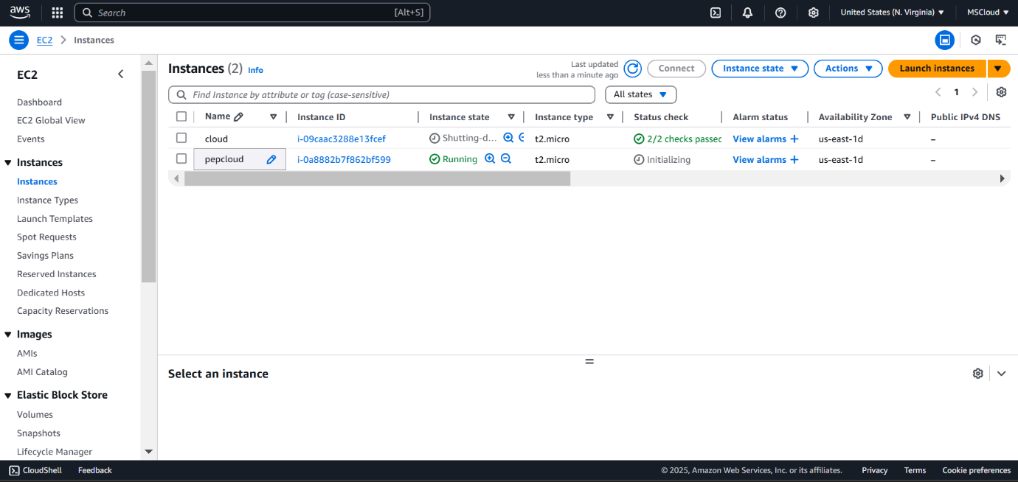,Launch instances and leave default in settings and then create volume (which is on the left menu

**Step 2: Now, in the volume list you get to go to actions and select attach to the volume**

**Step 3:** Navigate to AWS Cloudwatch.

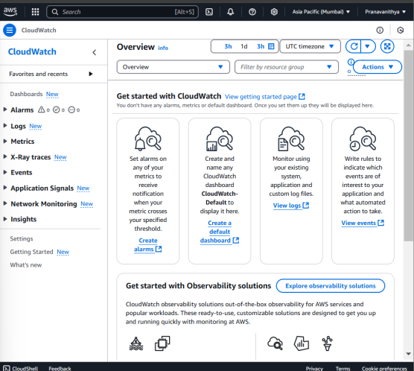

**Step 6:** after navigating to cloudwatch click on metrics on the left of the dashboard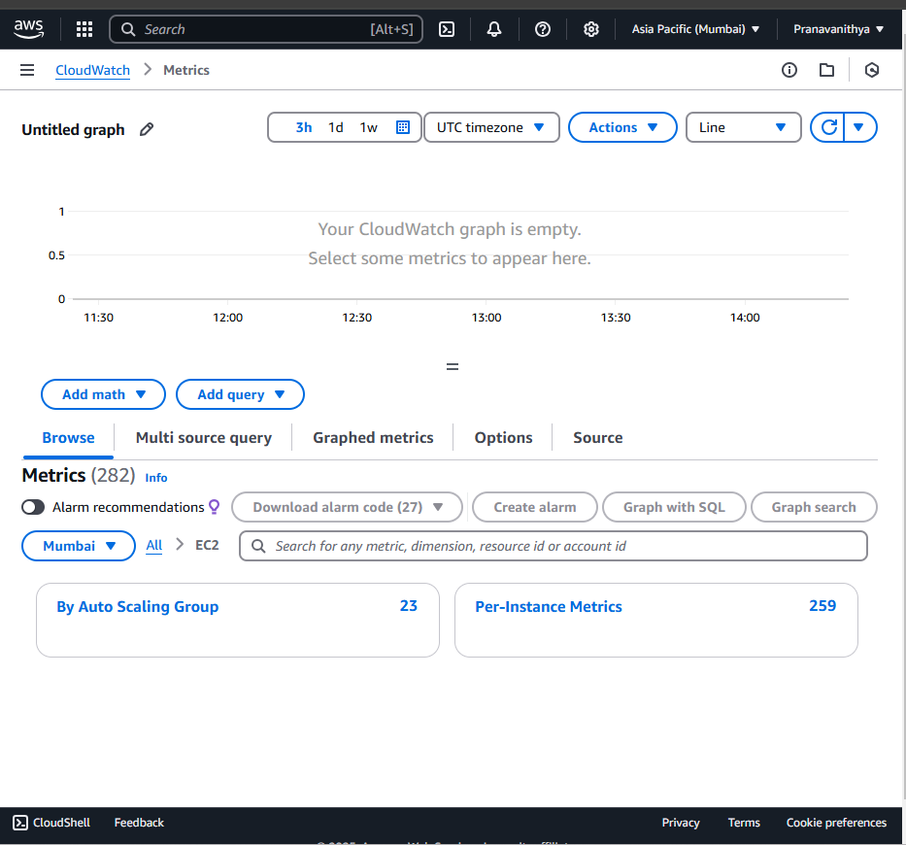

**Step 7:** You should now see a list of metrics for all your EC2 instances, such as:

Identify the specific EC2 instance you want to monitor (it will be listed by its instance ID).

Click on the metrics associated with your instance.

To view detail click Graphed metrics

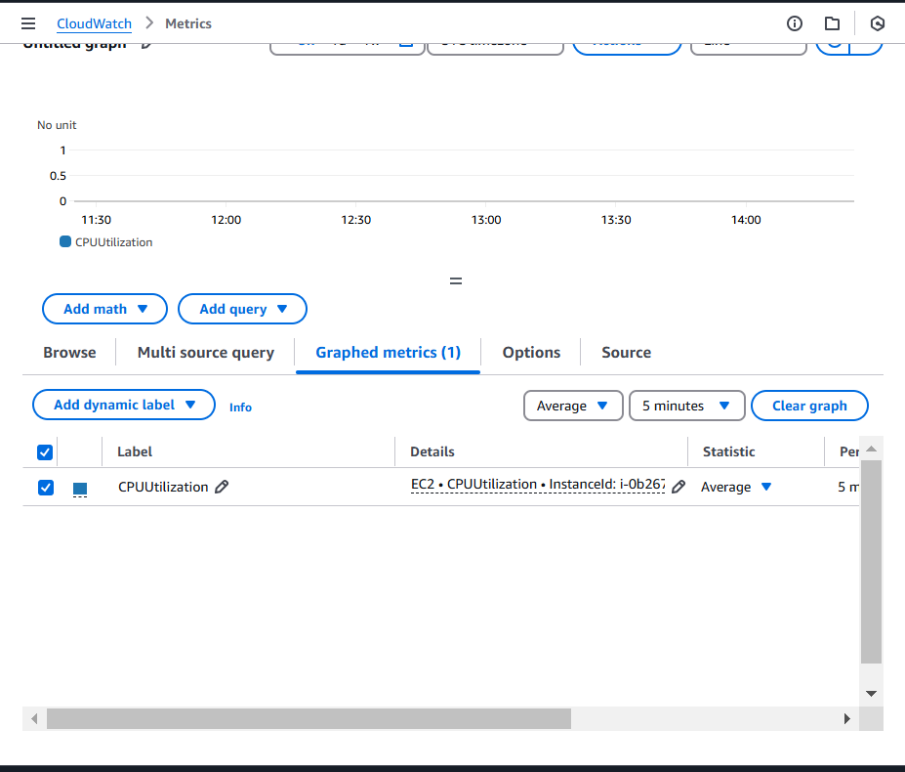

This is said to be the final output for this task

**Outcome**

* **Successfully enabling cloud monitoring on a cloud VM.**
* **Gaining insights into key metrics like CPU, memory, and disk usage.**
* **Setting up automated alerts for critical system issues.**
* **Understanding how to use monitoring tools for optimizing cloud performance.**

.